December 31, 2021

Good morning Tubman Families,

I hope this email finds you well. The purpose of this message is to help us prepare for a safe return to school on Monday, January 3, 222. As of right now the district plans to open schools for in person learning on Monday. Please find below various information to help clarify the district’s policies, and reinforce the protocols to help us stay healthy:

- COVID Reporting Protocol: If your child currently has COVID, or did over the break, please report the case by clicking here. CPS Contact Tracing will then email you the date of the return to school for your child. Once you receive that email, you may forward it to your child’s teacher. They will then provide asynchronous work within 24 hours following your email.
- Sick Protocol: Please have your child stay home if they are sick or have any symptoms regardless of their vaccination status. Click here for a list of symptoms that would require a student to remain home.
- Travel Protocol: If your child traveled over the break, follow directions from CDPH’S Travel Advisory. If your child is unvaccinated, and traveled to an “orange” state, please have them get tested with a viral COVID test 3-5 days after travel AND stay home and self-quarantine for a full 7 days.
- Vaccination Status: Please ensure we have your child’s vaccination card on file if fully vaccinated. In the case of needing to switch learning to remote instruction students with vaccination cards on file can return to school once remote learning launches. Please stop by the main office between 8am-3pm starting this Monday to have their vaccination card inputted in our system. Fully vaccinated means two weeks after their second dose.
- Vaccination: Students ages 5 and up are eligible for COVID vaccinations. If your child has yet to be vaccinated, click here for support in signing up for a vaccination.
- Reminder about delay for remote learning: Though asymptomatic, vaccinated students do not need to quarantine, educators are provided a 24 hour period to plan for remote instruction. If the district determines a full class needs to flip to remote instruction, all students in the class will be home during this 24 hour period. Then students who are vaccinated may return in person, while those unvaccinated, or sick, will access learning remotely. During that 24 hour window, the school will also pass out technology and materials for those learning from home remotely as needed.
- COVID Testing: If you would like to sign your child up for COVID testing please click here. Generally, students are called out of class to come down for testing on Friday afternoons.

The district will communicate with families directly if the learning model changes for students from in person to remote learning based on the cases reported. As of this morning, all of our homerooms are welcoming students back in person on Monday.

Wishing you and your families a very Happy New Year!

Principal Gibson and Assistant Principal Moore

Important Dates & Upcoming Events:
- December 26 - January 1: Kwanzaa
- December 31st: Omisoka
- January 1: New Year's Day
- January 3: Classes Resume
- January 5: LSC Meeting @ 6:00 p.m.
- January 7: Principal's Conversation at 10:00 a.m. (Click here to register)
- January 13: FOT Meeting at 6:00 p.m.
- January 17: Dr. Martin Luther King, Jr. Day - SCHOOL CLOSED
- January 27: End of 2nd Quarter
- January 28: Teacher Development Day - NO CLASSES FOR STUDENTS

Local School Council (LSC)

Our Tubman Local School Council supports and partners in the important work of monitoring our Continuous Improvement Work Plan, approving our annual budget, and evaluating our principal. We encourage you to reach out to the LSC representatives as you have questions about these three areas.

CPS has advised that public participation is the most effective way to engage our community during meetings so that all LSC members can hear and respond as helpful. Prior to each LSC meeting community members can sign up for public participation, or during the meeting itself. This process then follows the Open Meeting Act procedures transparently. All are welcome!

Assistance Fund Information

As a reminder, please keep our Assistance Program Fund in mind. Its purpose is to serve our community in times of need. Don't hesitate to reach out during this holiday season or any time throughout the year at the email address: assistanceprogramfund@gmail.com. More information can also be found on our website.

Next LSC meeting will be held on January 5th at 6:00 p.m.

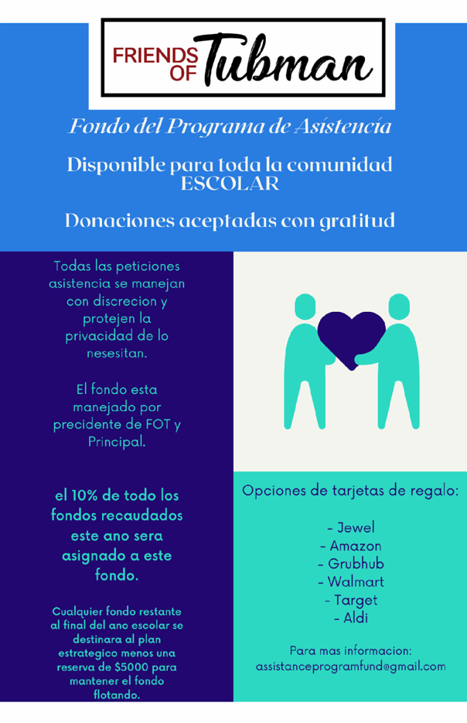

--
Kimberly Gibson
Principal
Harriet Tubman Elementary
2851 N. Seminary Ave.
Chicago, IL 60657
kgibson@cps.edu
https://tubmanelementarycps.org/
Phone (773) 534-5725
Fax (773) 534-5784

